import ReactDOM from 'react-dom';

ReactDOM.render(<App />, document.getElementById('root'));

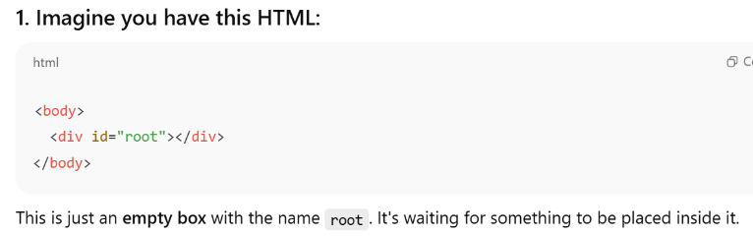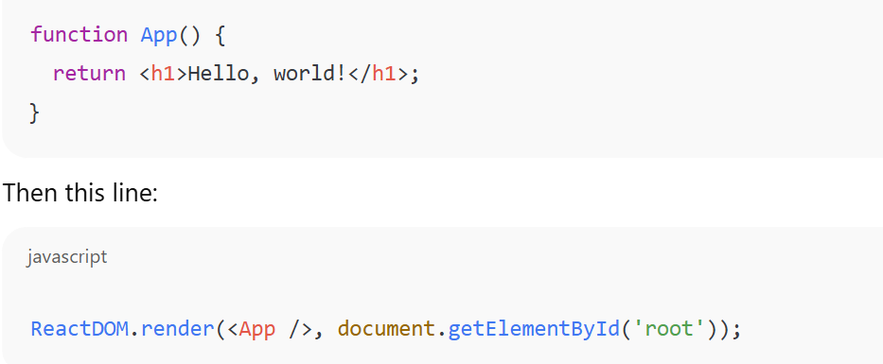



• 👉 **ReactDOM.render**: Ask React to show something on the screen.

• 👉 <App />: The thing you want to show (this is your main React component).

• 👉 document.getElementById('root'): Tells React **where** to show it — inside that empty <div id="root"> from the HTML.



I’ll now unzip the project and show you:

* The folder structure
* The key files (e.g., frontend/backend, main scripts)
* Technologies used

Let me proceed to extract and review the contents...

✅ The ZIP file contains a **React frontend project**. Here’s a quick breakdown of the structure:

**📁 Folder: frontend/**

This folder is a typical **ReactJS frontend project**. Here's what’s important:

**🔑 Key Files:**

| **File / Folder** | **Purpose** |
| --- | --- |
| package.json | Lists dependencies and project info |
| src/ | Contains the **React app source code** |
| public/ | Static files like index.html, icons |
| App.js | Main component, usually handles routing |
| Login.js, Signup.js, FormPage.js, Home.js | Individual React components/pages |
| index.js | Entry point that renders the app |

Perfect! Let’s start from scratch and walk through **how this React project works**, both **practically** and **theoretically**—step by step.

**🧠 Part 1: Theoretical Concepts — What is React?**

**🔷 What is React?**

React is a **JavaScript library** created by Facebook to build **user interfaces**, especially **single-page applications (SPAs)**.

**🔑 Key Concepts:**

| **Concept** | **Meaning** |
| --- | --- |
| **Component-based** | You build small reusable UI parts called components |
| **JSX** | Syntax that lets you write HTML inside JavaScript |
| **State** | Data that changes in a component (e.g., user input) |
| **Props** | Inputs passed from one component to another |
| **Virtual DOM** | React creates a copy of the real DOM to update UI efficiently |

**⚙️ Part 2: How is This Project Built?**

This project is created using **Create React App**, a starter tool to scaffold a React project.

**🛠 Project Setup (automated by Create React App)**

When you run:

npx create-react-app frontend

It automatically sets up:

* All configurations (Webpack, Babel, ESLint)
* A folder structure:

frontend/

├── src/ → All JavaScript and CSS for the app

├── public/ → Static files (like index.html)

├── package.json → Lists dependencies (like React)

**🔄 Flow of a React App (based on this project):**

**Step-by-step Execution Order:**

1. **index.html** (in public/)
   * This is the only HTML file that is served.
   * Has a <div id="root">, where the whole React app is injected.
2. **index.js** (in src/)
   * This is the JavaScript entry point.
   * It renders <App /> into the root element:

import ReactDOM from 'react-dom';

ReactDOM.render(<App />, document.getElementById('root'));

1. **App.js**
   * This is the **main component** of the app.
   * It usually contains:
     + Routing (navigation to different pages like login, signup)
     + Common layout (e.g., navigation bar)
2. **Other Components**
   * Login.js, Signup.js, Home.js, FormPage.js:
     + These are individual **pages/components** of your application.
     + They are used in App.js using routes.

**🧱 React Component Types**

There are two main types:

**1. Functional Component (used in this project)**

function Login() {

return <h2>Login Page</h2>;

}

**2. Class Component (older way)**

class Login extends React.Component {

render() {

return <h2>Login Page</h2>;

}

}

**🌐 Single Page Application (SPA)**

React creates a **Single Page App**, which means:

* There is only one HTML file (index.html)
* Navigation doesn’t reload the whole page
* URL changes are handled by **React Router**

**🧾 What is package.json?**

This file lists:

* **Dependencies**: All libraries (like react, react-dom, etc.)
* **Scripts**: Commands to run the app, like:

"scripts": {

"start": "react-scripts start"

}

To run the app:

npm install # installs dependencies

npm start # starts the app on localhost

**✅ Summary of What We’ve Covered:**

| **Topic** | **Summary** |
| --- | --- |
| React | JS library for building UI |
| Components | Reusable UI building blocks |
| JSX | HTML inside JS |
| State & Props | Manage and pass data |
| SPA | Single HTML file; React handles routing |
| Flow | index.html → index.js → App.js → Pages |
| Create React App | Tool to scaffold the project easily |